Day 17
Task 1 :
- create a node
- check if the tree is empty
  - if tree is empty, new node becomes the root
- if the tree is not empty perform a BST insert
- calculate balance
- if baclance factor is more than 1 or less than -1 tree is unbalanced. To balance we need to perform rotation to balance the tree
  - if balance is more than 1 its left heave, go for right rotation
  - vise versa
- keep repeating until balanced
AVL Tree Search Algorithm:
- start at the root
- compare search key with root node
- if search matched the root node return the node
- if the search is less than root node move the left childs node
- vise versa

Task 2:
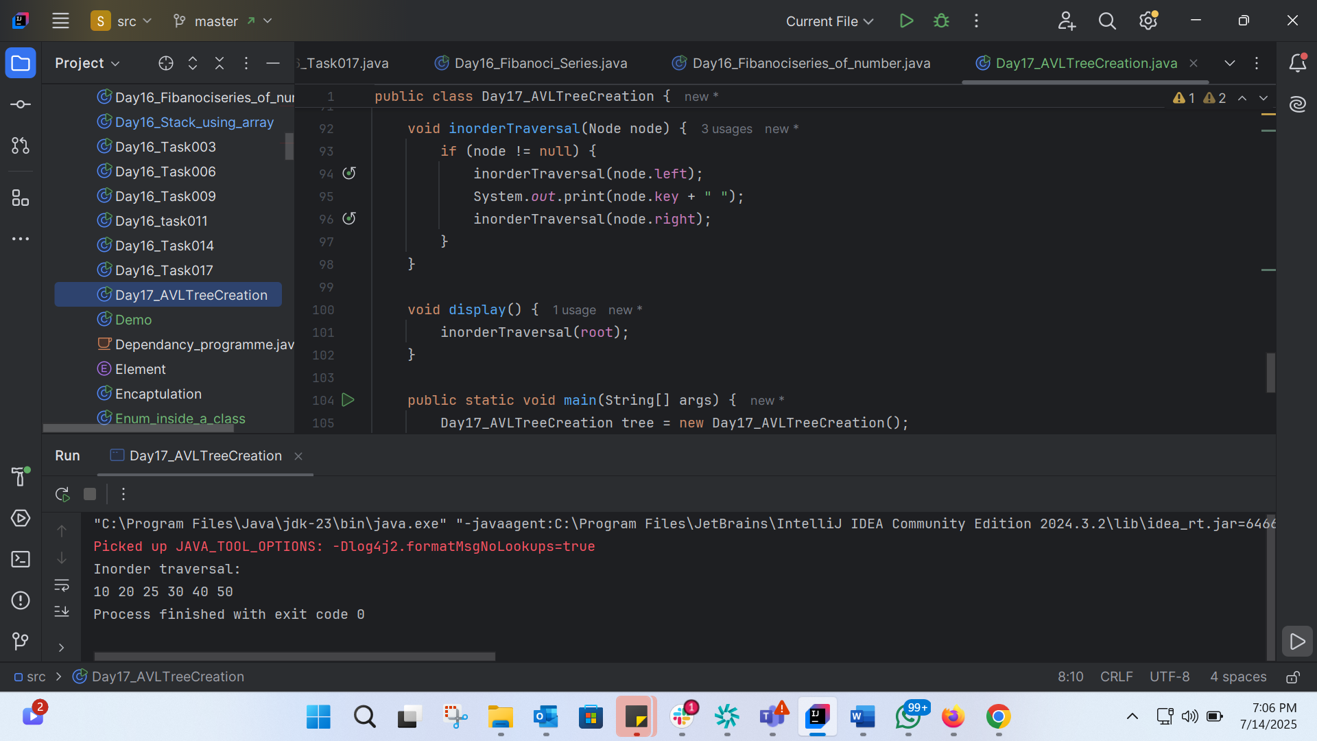

Task 3:
Algo for Red Black Tree
Insert an Element - Red Black Tree
1. Check if the tree is empty: If the tree is empty, insert the new node as the root node with a color of Black.
2. Insert as a leaf node: If the tree is not empty, insert the new node as a leaf node at the end with a color of Red.
3. Check for color conflicts: If the parent of the new node is Red and its neighboring node (parent's sibling) is also Red, then:
- Flip the color of both the neighboring node and the parent to Black.
- If the grandparent is not the root node, flip the color of the grandparent to Red.
4. Rotate if necessary: If the parent of the new node is Red and its neighboring node is empty or NULL, then perform a rotation:
- Left-Left Rotation: Rotate the new node and its parent.
- Left-Right Rotation: Rotate the new node and its parent.
5. Types of rotations: There are two types of rotations:
- Left-Left Rotation: When the new node is the left child of its parent, and the parent is the left child of its grandparent.
- Left-Right Rotation: When the new node is the right child of its parent, and the parent is the left child of its grandparent.
6. Conditions for rotation: Apply rotation when:
- The parent of the new node is Red, and the neighboring node is empty or NULL.
- Perform Left-Left Rotation or Left-Right Rotation based on the tree structure.
7. Color flipping after rotation: After rotation, flip the colors of the parent and grandparent nodes.
Task 4:
Code for red black tree
public class Day17_RedBlackTree {
private enum Color {
RED, BLACK
}
private static class Node {
int key;
Color color;
Node left;
Node right;
Node parent;
public Node(int key) {
this.key = key;
this.color = Color.RED;
this.left = null;
this.right = null;
this.parent = null;
}
}
private Node root;
public Day17_RedBlackTree() {
root = null;
}
private void leftRotate(Node x) {
Node y = x.right;
x.right = y.left;
if (y.left != null) {
y.left.parent = x;
}
y.parent = x.parent;
if (x.parent == null) {
this.root = y;
} else if (x == x.parent.left) {
x.parent.left = y;
} else {
x.parent.right = y;
}
y.left = x;
x.parent = y;
}
private void rightRotate(Node x) {
Node y = x.left;
x.left = y.right;
if (y.right != null) {
y.right.parent = x;
}
y.parent = x.parent;
if (x.parent == null) {
this.root = y;
} else if (x == x.parent.right) {
x.parent.right = y;
} else {
x.parent.left = y;
}
y.right = x;
x.parent = y;
}
private void fixInsert(Node k) {
while (k.parent != null && k.parent.color == Color.RED) {
if (k.parent == k.parent.parent.right) {
Node u = k.parent.parent.left;
if (u != null && u.color == Color.RED) {
u.color = Color.BLACK;
k.parent.color = Color.BLACK;
k.parent.parent.color = Color.RED;
k = k.parent.parent;
} else {
if (k == k.parent.left) {
k = k.parent;
rightRotate(k);
}
k.parent.color = Color.BLACK;
k.parent.parent.color = Color.RED;
leftRotate(k.parent.parent);
}
} else {
Node u = k.parent.parent.right;
if (u != null && u.color == Color.RED) {
u.color = Color.BLACK;
k.parent.color = Color.BLACK;
k.parent.parent.color = Color.RED;
k = k.parent.parent;
} else {
if (k == k.parent.right) {
k = k.parent;
leftRotate(k);
}
k.parent.color = Color.BLACK;
k.parent.parent.color = Color.RED;
rightRotate(k.parent.parent);
}
}
if (k == root) {
break;
}
}
root.color = Color.BLACK;
}
public void insert(int key) {
Node node = new Node(key);
node.parent = null;
node.left = null;
node.right = null;
Node y = null;
Node x = root;
while (x != null) {
y = x;
if (node.key < x.key) {
x = x.left;
} else {
x = x.right;
}
}
node.parent = y;
if (y == null) {
root = node;
} else if (node.key < y.key) {
y.left = node;
} else {
y.right = node;
}
if (node.parent == null) {
node.color = Color.BLACK;
return;
}
if (node.parent.parent == null) {
return;
}
fixInsert(node);
}
public void printTree(Node node, String indent, boolean last) {
if (node != null) {
System.out.print(indent);
if (last) {
System.out.print("R----");
indent += " ";
} else {
System.out.print("L----");
indent += "| ";
}
String sColor = node.color == Color.RED ? "RED" : "BLACK";
System.out.println(node.key + "(" + sColor + ")");
printTree(node.left, indent, false);
printTree(node.right, indent, true);
}
}
public void printTree() {
printTree(root, "", true);
}
public static void main(String[] args) {
Day17_RedBlackTree tree = new Day17_RedBlackTree();
tree.insert(10);
tree.insert(20);
tree.insert(30);
tree.insert(40);
tree.insert(50);
tree.insert(25);
tree.printTree();
}
}

